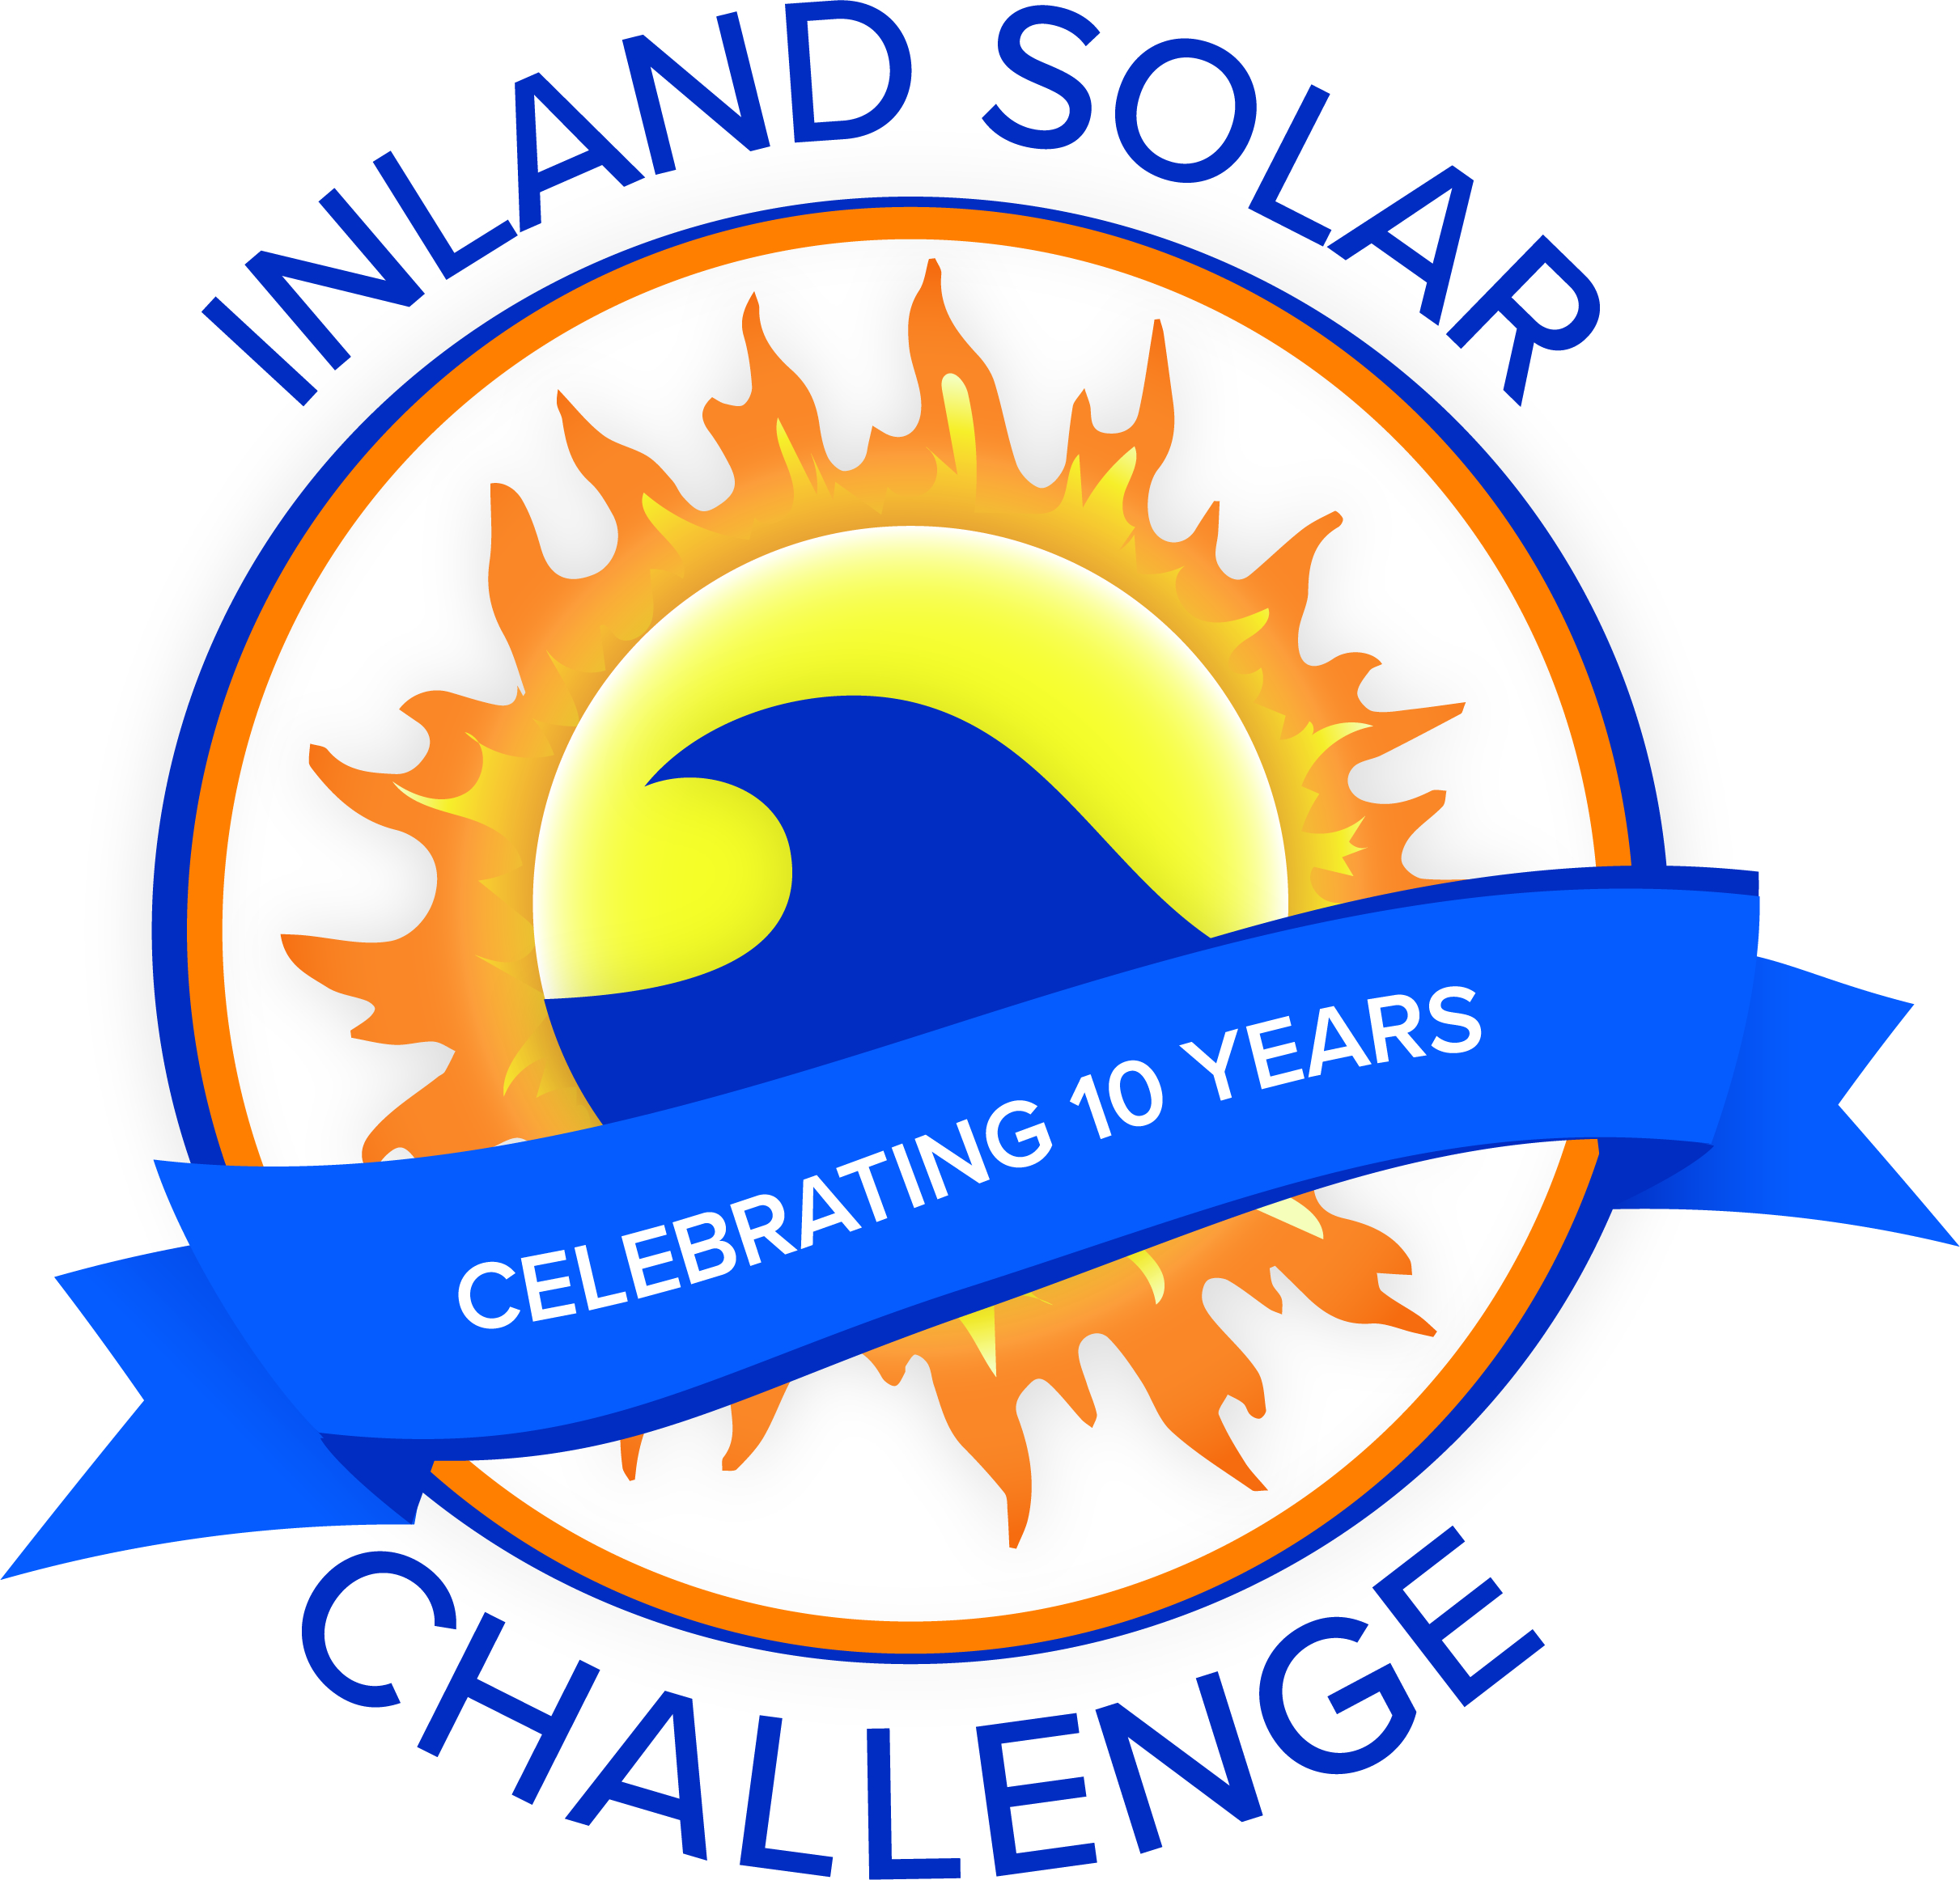
ISC Meeting Minutes
Meeting with ISC Committee
Date | time 9/22/2022 3:00 PM
Location: Crystal Creek - 35477 Oak Glen Rd., Yucaipa, CA 92399

Agenda Items
- Welcome and Introductions
  - San Bernardino Municipal Water Department- Devin Arciniega, Tiffany Currier
  - Yucaipa Valley Water District- Jennifer Ares, Matt Porras, Madeline Blua
  - East Valley Water District- Janett Robledo
  - West Valley Water District- Mary Jo Hartley
  - City of Redlands- Myra Sanchez
  - City of Colton- Cecilia Griego

- Approval of Minutes August 25, 2022
  - Mary Jo moved to approve, Devin seconded.
- Schools
  - 11 schools are expected to participate in the 2023 ISC event.
  - Cecilia reported that the teacher from Colton High School is participating.
  - Devin reported that Cajon is in at least for this year.
  - Janett reported that Indian Springs is participating as well.

- PSA Topic
  - The detailed PSA topic will be further discussed, but committee members agree that one of the four topics from “California’s Water Supply Strategy: Adapting to a Hotter, Drier Future” will be used. Topic for 2023 will be Demand Reduction. The PSA will have a component which involves the students researching a career which is tied to demand reduction.

- Rules
  - Committee members agreed that Battery Boxes should be kept in the boat build guidelines.

- Boat Build
  - Boat Build proposed for November 5th at Yucaipa Valley Water District.
  - There are three extra boat kits from 2021.
  - Schools can choose to pick up materials on or after November 5th and build their boat at another location.
- 501c3
  - Table to a future meeting

- Budget
  - Table to a future meeting

- Sponsorships
  - Table to a future meeting

- Additional Items/Discussion
  - Table to a future meeting

- Next Meeting (Pre Boat Build)
  - Table to a future meeting

- Adjourned at 4:00pm.

